|  |  |
| --- | --- |
| Canon PowerShot SX70 HS  Máy ảnh Canon PowerShot SX70 HS  Canon PowerShot SX70 HS 6 Canon PowerShot SX70 HS 5 Canon PowerShot SX70 HS 4 Canon PowerShot SX70 HS 1 | **Featured information:**  DIGIC 8 image processor  20.3MP CMOS sensor  Image stabilization mode  Continuous shooting up to 10 fps  Price : $ 600  **Specifications:**  Sensor Format  1/2.3"-Type CMOS  Resolution  Actual: 21.1 MP  Effective: 20.3 MP (5184 x 3888)  Size photo  -  Image Proportions  1:1, 3:2, 4:3, 16:9  Sensor Type  CMOS  Image Format  JPEG, Raw  Anti-Vibration  Optical image stabilization built into the lens  Lens Mount  **-** |

**Overview:**

Canon PowerShot SX70 HS camera, a compact camera but with the appearance of a typical DSLR camera, has compact dimensions of 127 x 90.9 x 116.6 mm, weight of only about 608g, convenient for users to use. Can carry with you every day.

The camera is equipped with an OLED electronic viewfinder with 2.36 million dots, just enough to help easily observe and track scenes clearly into view. The 3.0" tiltable LCD screen is a big plus for the Canon SX70, especially for users who want to vlog or take selfies.

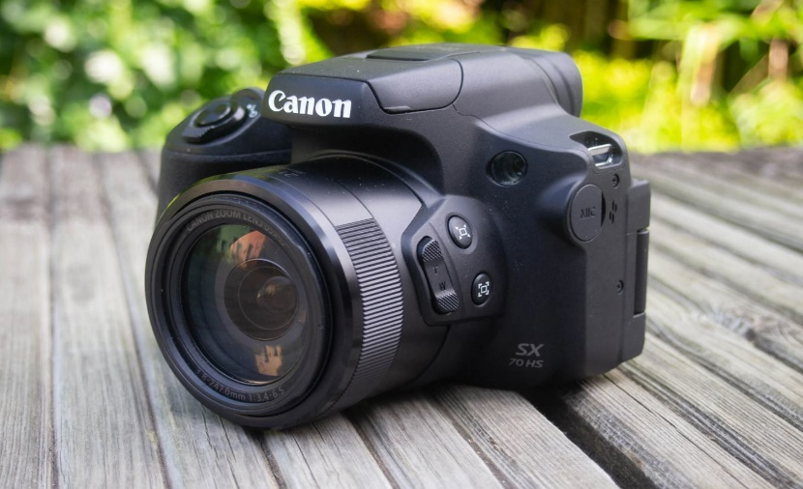

The 20.3MP CMOS sensor combined with the DIGIC 8 image processor, Canon PowerShot SX70 HS delivers impeccable image quality and speed. The camera allows capturing still images at up to 10 fps, recording UHD 4K video and creating time-lapse movies up to 4K right on the camera.

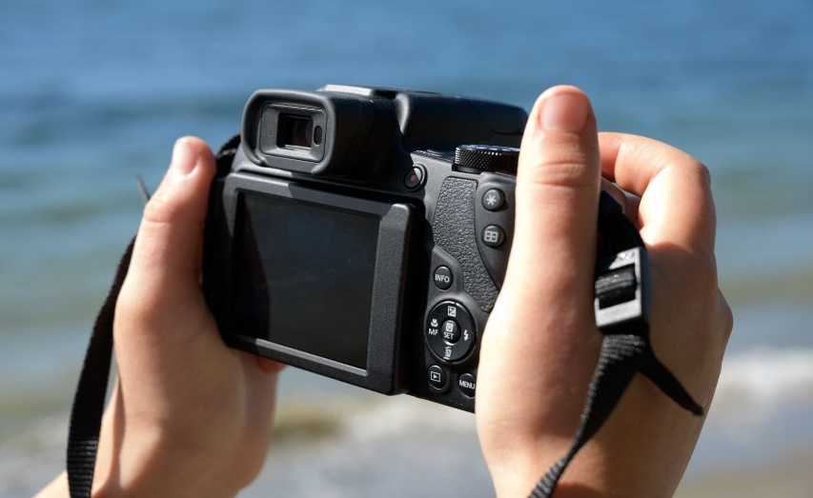

This perfect combination of sensor and processor helps create sharp frames, minimizing noise so users can shoot even in low light.

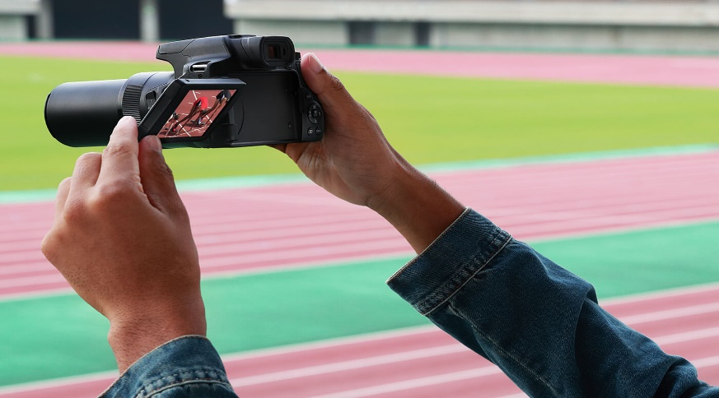 Not stopping there, Canon also added an image stabilization system right in the lens, so vibration when shooting is also minimized.